Shabbos Stories For
parshas toldos 5785
Volume 16, Issue 10 29 Cheshvon 5785/November 30, 2024
Printed L’illuy nishmas Nechama bas R’ Noach, a”h
For a free subscription, please forward your request to keren18@juno.com
Past emails can be found on the website – ShabbosStories.com

The Rebbe and His Chasid

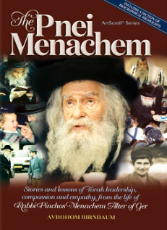
Before the Pnei Menachem became the Gerer Rebbe, he gave advise to a Chasan to accept upon himself a routine, that every evening when he comes home, the first thing he should do is pick up a Gemara from the Shas he received from his father-in-law, and learn one Amud, one side of a page. It was not that he should simply learn an Amud of Gemara each night, but that he should learn it specifically when he arrives at home. The Chasan agreed.
Years later, one Chol HaMo’eid Succos, this young man was in line with his three sons to greet the Pnei Menachem, and wish him “A Gut Mo’eid”. The Rebbe asked him, if possible, to return after Simchas Torah. When he returned, the Rebbe asked him for the names of his three sons, and asked how the oldest boy was progressing in his Torah studies and Yiras Shamayim.
The father replied that Baruch Hashem, he was doing very well, and he was a true source of Nachas for them. The Rebbe then inquired, “What about the other two? How are they doing?”
The young man replied, “They are not doing as well as the first one.” The Rebbe asked him if he was still learning an Amud of Gemara each night when he got home, and the man said that after the birth of his second son, it was too difficult for him to continue doing that practice, and he had stopped.
The Pnei Menachem said, “Your oldest son was born during the time when you were strengthening the Torah in your home every night, while the others were born after you had given it up. That is why there is a difference in your children. However, Im Yirtzeh Hashem, you will still have more children. If you accept to learn the Amud of Gemara each night again, and you will see that you will have good children!”

Reprinted from the Bereishis 5785 email of Rabbi Yehuda Winzelberg’s Torah U’Tefilah.

Cause and Effect – How
Our Words Impact Others
By Rabbi Dovid Goldwasser



As I walked down the street one morning, deep in thought, I looked up momentarily to get my bearings. As I did, I saw a neighbor approaching from the opposite direction. His head was bent toward the ground, and he seemed troubled and withdrawn, as I greeted him with a warm “Good morning.” He glanced at me, but didn’t reply. I felt I had to add something more, so I brightly said, “How’s your avodat hakodesh – holy work?”
His head snapped up briefly, in shock, as if I had said something wrong. He then quickly lowered his eyes back down and silently walked past me.
Perturbed that I had perhaps unintentionally offended the man, I thought to myself that if only one could more often remember to follow the dictum of our Sages, “סיג לחכמה שתיקה – silence is a protective fence for wisdom.” But, I sadly concluded, the words had already been spoken out loud. The program of the day that ensued became exceedingly hectic and eventually the morning encounter slipped my mind.
When I returned home late that evening I got the message that the man I had met in the morning had called, and would be trying to reach me again. I speculated that he had been so upset by my remark that he had found it necessary to pursue the matter with a call.
When we finally spoke, the man launched into a personal narrative. He told me that he was a fundraiser for a Jewish communal organization and the past year had not been very productive. In fact, the funds he had raised were less than his salary, and he just didn’t feel it was proper to be recompensed. He had been on his way to hand in his resignation.
As he walked by me that morning, feeling sorry for himself, his self-esteem was in the dumps, and feeling quite miserable, my question had blown him away. He couldn’t believe that somebody actually framed his work in the realm of avodat hakodesh. He didn’t think anybody cared what he did for a living. Like a bolt of lightning my words struck him to the core, and he wondered if I was a heavenly messenger — a sign from heaven.
Suddenly, he felt revitalized and reenergized, and he decided to give his assignment another go. Actually, his day turned out to be a very successful one. In that one day he raised more money than he had the entire year. He had called just to let me know the beneficial effect of my casual greeting.
You can never gauge the consequences of your words.

Reprinted from the website of Hidabroot

Rabbi Chaim Kanievsky – Add “Achashverosh” to the Patient’s Name

In the name of Rabbi Yehudah Yosefi, it is told that a young man recently approached Rabbi Chaim Kanievsky for a blessing. The rabbi asked the young man for his name, and the young man replied: “Nimrod.”
In response, the rabbi said to him: “Nimrod? No, not Nimrod, rather “Shaltiel”.
Those who heard, raised an eyebrow, knowing Rabbi Kanievsky’s sensitivity to the name “Nimrod”: Why did the rabbi choose to call the young man such a rare biblical name, “Shaltiel”?
The young man returned home and informed his parents that from now on his name would be Shaltiel. His mother said to him: “Not from today…already from the day of your circumcision, that’s what we called you, but later we thought it was too old-fashioned so we changed to Nimrod.”

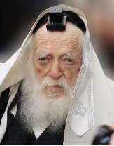
Rabbi Chaim Kanievsky

Another story tells Rabbi Yosefi: A Jew came to Rabbi Kanievsky and told him about his father who was very sick, and asked him whether to add him a name as a segulah for a complete recovery. Rabbi Kanievsky’s answer was: “Call him Antiochus.”
When the questioner expressed his amazement, the rabbi replied: “Then Achashverosh”. The questioner returned to his father and told him the Rabbi’s response. The bed-ridden father burst into tears and admitted that he had converted without circumcision. Such conversion is not valid, and therefore, in fact he is a complete non-Jew…
Another story is told by Rabbi Reuven Reich, the son-in-law of the Lakewood Rosh Yeshiva. Decades ago, a young boy who liked to photograph the holy Tzaddikim (Sages) of the generation, came to the home of Rabbi Kanievsky.
He went into the rabbi’s home and took a rare picture of the rabbi feeding a cat who came looking for food. After the photo was taken by the young man, Rabbi Kanievsky asked him to stop filming, but the young man continued to take more pictures. In response, Rabbi Kanievsky got upset and said, “that’s rude”, “I’m telling you to stop filming!” At this point the boy panicked, he opened the film (for those who remember what a film was …) and burned all the pictures.
Twenty-five years passed since then, the young man had already raised a family and was blessed with a bunch of boys. Before the Bar Mitzvah of one of his children he came to Rabbi Kanievsky’s house and when he entered the rabbi’s room, the rabbi looked at him and immediately said: “I’ve been searching for you for 25 years. You are the boy who photographed me feeding the cat; I wanted to ask forgiveness for getting angry with you”.
How special is the fear of sin and the power of perception of such a great Sage, immersed in non-stop Torah learning the vast majority of the day.
Courtesy of the Dirshu website

The Power of Belief in the Words of Our Sages
By Rabbi David Ashear

Jeffrey’s* father ingrained in him from a young age to have emunas chachomim. In 2010, Jeffrey was 37 years old and still unmarried. His Rav told him, “You need to learn Torah every day.”
“I have a difficult schedule,” he replied, “and I must rush to work. I don’t have time.”
The Rav then said, “If you commit to learning Torah every day from 6:15 am sharp until 7:00, I guarantee you will be engaged by Tu BiShevat.”
This conversation took place at the start of November with Tu BiShevat just a few months away. Jeffrey believed the words of his Rav. The next morning, he came at 6:10 to learn. For the next few months, he always arrived early to fulfill his part of the deal. The week of Tu BiShevat, he got engaged. And he has been learning ever since.
The story did not end there. A year later, he and his wife were blessed with a beautiful baby girl. Three years went by without another child. They went to Eretz Yisrael on vacation. Jeffrey went to R’ Chaim Kanievsky for a bracha. “We’ve been waiting for another child for three years,” he said, adding, “and I really want a baby boy!”
At the time, Jeffrey was wearing a bracelet and a ring, both of which had sentimental value. R’ Chaim told him to remove his jewelry, because it was forbidden for a man to wear items befitting a woman.
“I will listen to anything the Rav tells me to do, but can the Rav please give me a bracha that I will have a baby boy?”
R’ Chaim said yes. Exactly nine months later, his wife gave birth to a healthy baby boy. He believed in the words of the Gadol, and Hashem rewarded his belief. (Excerpted from the ArtScroll book – “Living Emunah on Shidduchim”)

Reprinted from the Sukkos 5785 email of The Weekly Vort.

The Guest Who
Wore All White
By Tuvia Litzman

A Jewish woman in Jerusalem who was not blessed with children after many years of marriage, felt more and more distressed with each passing year. She visited many righteous people and prominent rabbis and asked them to bless her, but she remained childless. One day, a woman acquaintance gave her a strong recommendation: many women in a similar situation had received the gift of children after praying at the tomb of our matriarch “Mama Rachel” in Beit Lechem ("Bethlehem').
The childless woman decided to take upon herself to say the whole book of Tehillim (Psalms) once a week at the gravesite of “Mama Rachel”. She fulfilled her commitment, and to her immense delight she became pregnant and later that year gave birth to a baby boy.
This became cause for pure joy and excitement for all her family and friends and neighbors, since she had been married for twenty years until this first child. The new mother knew in her heart that he was born in the merit of our Matriarch Rachel, and she felt strongly that she wanted to give "Mama Rachel" a personal invitation to the brit mila (circumcision ceremony). She wrote a nice invitation, put it into a white envelope and made a special trip to Beit Lechem in order to place the invitation on "Mama Rachel's” tomb.
When she approached the tomb, she saw that a large number of Israeli soldiers were positioned around the building. The soldiers explained to the woman that riots were going on and the Arabs were throwing rocks at anyone who attempted to approach. They refused to allow her to go inside, not even for the brief two minutes she was begging them for. They kept repeating that it was too dangerous.

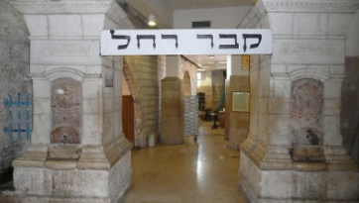

She, however, refused to give up. She approached a small group of the Palestinian policemen and in Arabic explained the reason for her visit. She pleaded with them to let her go inside. They appreciated her plea, the highest ranking one gave an order, and four armed Arab policemen escorted her into the building over the grave. She put the envelope on the tomb, expressed a few words of warm gratitude, said a few chapters of Tehillim and left the place, again escorted by the policemen, whom she thanked.
A large number of people came to the circumcision - relatives and friends, and others as well who had heard about the 'miracle' birth after twenty years. Everyone wanted to participate in the exalted joy of the special occasion. One close friend even arranged for a video photographer to film the event.
A few minutes before bringing the boy into the Covenant of Abraham, a beautiful, refined-looking woman entered the hall. She wore a long white dress and made such a strong impression that many women stood up and pressed her hand, despite the fact that they had no idea who she was.
The woman approached the mother of the boy, embraced her, kissed her on her cheeks and wished her 'Mazal Tov'. The brit was performed and everybody felt the exceptionally great joy. After a few days the family received the video film of the brit, and a CD in order to watch the movie on their computer. As they stared at the screen, they saw something very strange: one of the women got up from her seat, smiled, and pressed her hand - into thin air! After that, another woman got up and pressed her hand in the air. This happened a few times, always with a different woman.
Then, they saw how the mother of the boy made a motion as if embracing somebody and offering her cheeks for a kiss - but without seeing any person doing it! They watched the movie over and over again with the same strange events repeating themselves. Finally, they realized that the video camera simply did not catch the beautiful woman dressed in her white frock. According to Jewish custom, if you are personally invited to a brit mila, it is such an important occasion that you have to come….

Reprinted from the Succos 5785 email of Lekavod Shabbos. Reprinted from the book – “Chassidic Gems II.”

The Seemingly
“Unlucky” Groom
From the Desk of Yerachmiel Tilles

Rabbi Yitzchok Greenberg recalled a story he had heard years earlier.
About 200 years ago, in a shtetl in Eastern Europe, the entire community chipped in money to help a poor bridegroom get started in a business. Following the community’s advice, the groom bought a horse and wagon and drove to the market to buy flour, which he would then resell in the village.
One day, he bought sacks of flour with the remainder of his money, and carefully loaded them onto the wagon. While riding home, a violent gust of wind flipped his wagon over. All the sacks of flour were flung onto the rocky ground. The sacks burst open and the wind blew the flour away. The young man turned upright the empty wagon, and feeling totally distraught drove straight to his Rebbe. The sad groom told the Rebbe about the terrible misfortune.
After a few minutes of deep meditation, the Rebbe said, “G-d made that wind. I have to call Him to a din Torah (a rabbinical court hearing).”
The Rebbe wept and pleaded the case for the groom. Minutes passed. Finally, the Rebbe looked up and smiled. “You have won the case. Now, return to your village and all will be well.”
On the road home, the groom’s wagon got stuck in the mud. The unlucky groom took a broken branch and tried to dig out the wheel. The branch struck against something hard and he pushed it out of the mud. It was a chest! The young man pried it open and, behold, it was overflowing with gold coins and jewels.
After searching in vain for its owner, a judge ruled that since apparently robbers had hidden this treasure in the ground and there was nobody to whom he could return the treasure, the groom was allowed to keep it. The couple invested their fortune wisely, and became known throughout the land for their generosity and warm hospitality.

Excerpted from the Sukkos 5785 email of KabbalaOnline.org, a project of Ascent of Safed in Israel.

Minyan at Midnight

He walked down the main street that connects the two cities. As he passed Beilinson Hospital, Uri saw a frum Yid standing outside, calling him over. “Can you help us with a minyan?”
“A minyan?” Uri asked in amazement. “Not even at Itzkovitz (a well-known minyan factory) are Yidden looking for a minyan at this hour!”
“You’re correct,” the Yid said. “My father is on his deathbed with only moments left to live. We’d like to have a minyan present when his soul returns to its Maker.”
Uri didn’t know what to do. He hadn’t expected his Yom Tov night to have such a turnout. The esrog he’d worked so hard for turned out to be pasul, he’d walked in the middle of the night to Petach Tikvah and back, and now he was being asked to join a minyan?
Still, how could he say no to a son about to lose his father? He followed the Yid into the hospital to join them for their father’s last moments. However, the dying father’s neshama wasn’t leaving him too quickly, and the overtired Uri was losing his patience. The children of the father begged him to remain, and so he busied himself with a Mishnah Berurah.
When the father’s neshama finally departed, Uri was ready to leave right away, but the son of the deceased further requested that he wait to escort him home to Bnei Brak, and Uri agreed. Finally, at 3 a.m., the two began their way home. At one point, the Yid turned to Uri and said, “I know why I’m walking on Jabotinsky Street at this hour, but what are you doing out here in the middle of the night?”
Uri explained to the Yid about how he and his chavrusa had learned the halachos of arba minim, how they’d checked esrogim for the dealer to score for themselves a “diamond” esrog, how only tonight he realized its pasul, and how he’d walked all the way to Petach Tikvah to inform his chavrusa of their predicament.
“Do you have parnassah?” the Yid asked Uri suddenly. Uri was beside himself. “It’s Yom Tov, and it’s the middle of the night. What are you asking, whether my rosh kollel pays on time?”
The Yid said, “I’m not asking for no reason. Tell me your situation.”

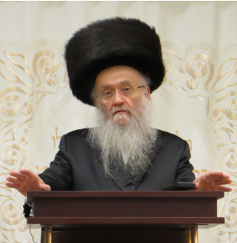
Rav Yosef Efrati

Without a choice, the tired Uri told him that finances weren’t going so easily for him and his wife.
“Well then,” the Yid then said, “I have an offer for you. I work in the kashrus department of Rav Yosef Efrati’s organization. The Rav has been looking for a competent talmid chacham to take upon himself the responsibility for the terumos and maaseros of the fruits and vegetables. Usually, the work needs to be done early in the morning and doesn’t require a lot of time. It’s a job that’ll still allow an avreich to continue his learning.”
“So just put an ad in the newspaper. You’ll certainly find someone qualified for the job.”
“It’s not so easy. We’re talking about a very serious responsibility. Such a job requires a true yorei Shamayim who recognizes the severity of the matter — who can wake up early in the morning and ensure that all the fruits and vegetables are tithed properly. Not just anyone who answers an advertisement is fit for such a job. We need someone who can’t sleep at night because he’s afraid of Jews being oveir the issur of tevel, and you’ve proven yourself to be such an individual. If you’re prepared to lose your sleep because of one person’s esrog, then certainly you’ll do the same with the whole country!”
Today, Uri oversees the terumos and maaseros department of the Vaad Hakashrus of Rav Yosef Efrati. He remains immersed in learning and support his family comfortably, all in the merit of his mesiras nefesh for the fulfillment of mitzvos b’hiddur and his desire to bring Hashem nachas ruach.

Reprinted from the Sukkos 5785 email of Zichru Toras Moshe.

The Rabbi and
the Rich Man
By Rabbi Amrom Malka

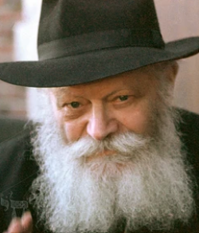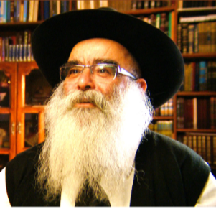
The Lubavitcher Rebbe and Rabbi Amram Malka

We came to Israel from Casablanca when I was five, and for the first seven years, we lived in a migrant camp in Pardes Chana. My twin brother Eliyahu Moshe and I studied in a government school, but when our parents realized how far it was from traditional Judaism, they moved to Bnei Brak, where we received a proper Torah education.
When we graduated from the school in Bnei Brak, they sent us to the Chabad yeshivah in Lod and then to Kfar Chabad. In those yeshivot, the children of Yemenite and Moroccan families learned alongside the sons of old-stock Russian Chabad families. And so did we discover the world of Chabad, imbibe its spirit, and eventually adopt its way of life as devoted chasidim of the [Lubavitcher] Rebbe. That is why it was only natural that I joined a group of students who were going to study in New York, in the Rebbe’s court — a program known today as “kvutzah.”
When we arrived in 1965, I was thrilled to be the first member of the Malka family to ever visit the Rebbe. A few weeks later, after Rosh Hashanah, a friend of mine asked me whether I could help build the Rebbe’s sukkah. “But no looking around, and no questions,” he warned me. Of course, I agreed, while wondering to myself how I — a simple, wide-eyed yeshivah student — had landed the privilege of working for the Lubavitcher Rebbe.

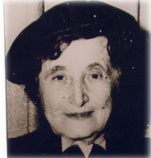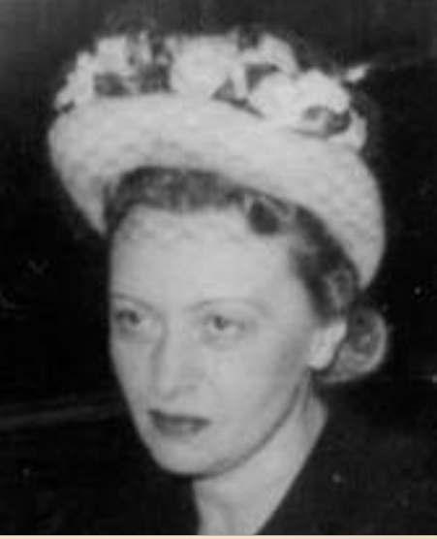
Rebbetzin Nachama Dina and Rebbetzin Chaya Mushka

First, we carried sukkah walls from the basement of 770 up to the second floor, which was where the Previous Rebbe had lived. There I met the Previous Rebbe’s wife, Rebbetzin Nechama Dina, for the first time. Until her passing in 1971, her son-in-law and her husband’s successor, the Rebbe, used to have meals during festivals in this apartment, and there, on the balcony, we built the sukkah that would host them.
Next, we built a sukkah at the Rebbe’s home on President Street — which was another first for me. The Rebbe’s wife, Rebbetzin Chaya Mushka, opened the door for us when we came, and after we finished working, she brought out some fruit and other treats. “You worked hard,” she explained, and encouraged us to partake.
Later, one of the Rebbe’s secretaries handed me an envelope with twenty-five dollars. “This is from the Rebbetzin,” he said. She didn’t want me to work for free. Now that I knew the protocol, on Simchat Torah, I was once again called to the Previous Rebbe’s apartment to help set up some tables, and I kept being invited back to do various jobs for the Rebbe and his family.
That Passover, I helped out with the pre-holiday cleaning, and then again I helped serve and clear at the Seder. This meant that I also had the honor of sitting at the Rebbe’s Seder table, alongside several venerable Chabad chasidim. Rebbetzin Nechama Dina instructed me to put a full setting at the head of the table, for her late husband, the Previous Rebbe. Of course, nobody sat there, and the Previous Rebbe’s two sons-in-law, the Rebbe and Rabbi Shmaryahu Gurary, sat on either side.
The Rebbe made a point of saying “thank you” every time I served him, and then again when I removed his plate. Of course, we served the Rebbe first, but he would not touch his food until he saw that everybody — including us waiters — had a portion.
I couldn’t always follow the discussions in Yiddish taking place on the other end of the table — but I was enchanted by the atmosphere in that room all the same. On Shavuot, once again, I was asked to help during the holiday meal, but this time I reluctantly declined. The Rebbe wanted chasidim to go out and visit synagogues outside of Crown Heights on the first night of the holiday in order to bring extra holiday joy to other communities and share chasidic teachings. So even though it meant missing the meal, I wanted to go on “tahalucha,” as this program is called.
When I made it back to 770 later that night, I hadn’t yet prayed or eaten. But suddenly, I got word that the Rebbe had summoned me; apparently, he had noticed my absence at the meal. By then, the stairs leading up the second floor of 770 were packed with chasidim who had come back from tahalucha and were waiting for the Rebbe to come out and greet them. And so, with no other way in, I was hoisted up and passed over the crowd until I was standing right behind the Rebbe.
“Have you prayed yet?” he asked me, implying that if I had prayed already I was invited to join the meal at his table! I told him that I had not, but before he left, he checked again to see if I was ready to have the meal. I was struck by the fatherly care and sensitivity that the Rebbe showed me; I was just a young boy who helped around the house!
That summer, Zalman Shazar, then the President of Israel, paid the Rebbe an official state visit. Before he arrived, the Rebbe’s secretary, Rabbi Leibel Groner, asked me to help prepare the Rebbe’s office. Together with a few other boys, we got to work packing up and clearing the mounds of books the Rebbe had either received as gifts or had been studying from.

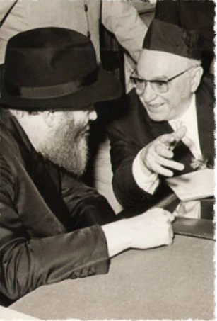
The Lubavitcher Rebbe with Israeli President Shazar in 1966
Then, handing me a few rags for the walls and windows, Rabbi Groner asked me to stay on for a little longer to put on the finishing touches.
At one point, I noticed a stack of pictures sticking out of a half-open drawer in the Rebbe’s desk. When I got a closer look, I saw that it was a family photo of people that I recognized. “They must have sent this picture of themselves to the Rebbe,” I thought to myself. “I also want to send the Rebbe a picture of my own family.”
I wrote to my parents, and they soon sent me a picture of the entire Malka family which I put into a beautiful frame. Before I returned home, I had a private audience with the Rebbe. When I came into his room, along with my letter, I also presented the framed picture in an envelope, with a little dedication and the names of my family members on the back.
The Rebbe read my letter, gave me a blessing, and then opened the envelope. After studying the picture for a moment, he took the photo out of the frame and laid it on the table. Then, still holding the empty frame, the Rebbe said: “When people would bring their bikurim, the offering of the First Fruits, to the Temple, the Mishna says that the wealthy would bring their offerings in gold and silver containers, while the poor brought theirs in wicker baskets. The wicker baskets were given to the priests along with the fruit, while the expensive containers were returned to their owners.”
Then, handing me the frame, he added, “I’ve taken your picture, but, like they did with the wealthy people, I’m giving the frame back to you.” When the Rebbe returned that frame to me, he truly made me feel rich.

Reprinted from the Hoshana Rabbah 5785 email of “Here’s my Story [with the Lubavitcher Rebbe, zt”l]”, a project of The JEM Foundation. Today Rabbi Malka is one of the senior members of the Chabad community in Rishon Litziyon, Israel, He was interviewed in his home in February of 2012.

